1 run

training 1 epoch...

13.981770515441895 seconds used......

1 training finished! average train loss: 1.0316560406770026

evaluating...

Confusion matrix, without normalization

[[ 18 16 11]

[ 22 140 24]

[ 42 118 194]]

Normalized confusion matrix

[[0.4 0.35555556 0.24444444]

[0.11827957 0.75268817 0.12903226]

[0.11864407 0.33333333 0.5480226 ]]

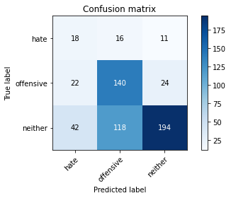

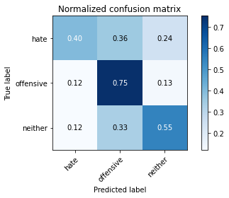

precision recall f1-score support

hate 0.22 0.40 0.28 45

offensive 0.51 0.75 0.61 186

neither 0.85 0.55 0.67 354

accuracy 0.60 585

macro avg 0.53 0.57 0.52 585

weighted avg 0.69 0.60 0.62 585

average eval_loss: 0.85758762160937, accuracy: 0.6017094017094017

training 2 epoch...

14.081026792526245 seconds used......

2 training finished! average train loss: 0.839539284152644

evaluating...

Confusion matrix, without normalization

[[ 30 12 3]

[ 27 147 12]

[ 55 131 168]]

Normalized confusion matrix

[[0.66666667 0.26666667 0.06666667]

[0.14516129 0.79032258 0.06451613]

[0.15536723 0.3700565 0.47457627]]

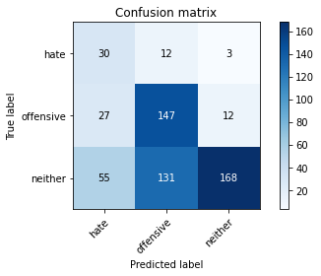

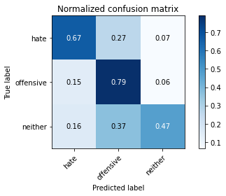

precision recall f1-score support

hate 0.27 0.67 0.38 45

offensive 0.51 0.79 0.62 186

neither 0.92 0.47 0.63 354

accuracy 0.59 585

macro avg 0.56 0.64 0.54 585

weighted avg 0.74 0.59 0.60 585

average eval_loss: 0.9286508738994599, accuracy: 0.5897435897435898

training 3 epoch...

14.170877456665039 seconds used......

3 training finished! average train loss: 0.6184575717364039

evaluating...

Confusion matrix, without normalization

[[ 27 13 5]

[ 14 149 23]

[ 41 105 208]]

Normalized confusion matrix

[[0.6 0.28888889 0.11111111]

[0.07526882 0.80107527 0.12365591]

[0.11581921 0.29661017 0.58757062]]

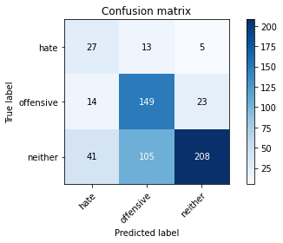

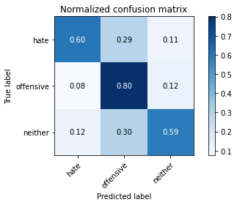

precision recall f1-score support

hate 0.33 0.60 0.43 45

offensive 0.56 0.80 0.66 186

neither 0.88 0.59 0.71 354

accuracy 0.66 585

macro avg 0.59 0.66 0.60 585

weighted avg 0.74 0.66 0.67 585

average eval_loss: 0.811634486913681, accuracy: 0.6564102564102564

training 4 epoch...

14.301951885223389 seconds used......

4 training finished! average train loss: 0.35943951244865147

evaluating...

Confusion matrix, without normalization

[[ 34 1 10]

[ 44 80 62]

[ 47 27 280]]

Normalized confusion matrix

[[0.75555556 0.02222222 0.22222222]

[0.23655914 0.43010753 0.33333333]

[0.13276836 0.07627119 0.79096045]]

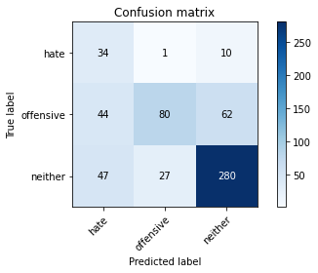

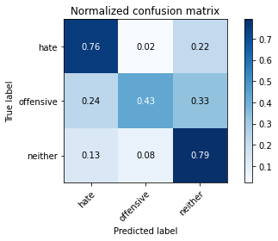

precision recall f1-score support

hate 0.27 0.76 0.40 45

offensive 0.74 0.43 0.54 186

neither 0.80 0.79 0.79 354

accuracy 0.67 585

macro avg 0.60 0.66 0.58 585

weighted avg 0.74 0.67 0.68 585

average eval_loss: 0.8460220774014791, accuracy: 0.6735042735042736

training 5 epoch...

14.40485692024231 seconds used......

5 training finished! average train loss: 0.2224464134446212

evaluating...

Confusion matrix, without normalization

[[ 29 9 7]

[ 41 122 23]

[ 64 87 203]]

Normalized confusion matrix

[[0.64444444 0.2 0.15555556]

[0.22043011 0.65591398 0.12365591]

[0.18079096 0.24576271 0.57344633]]

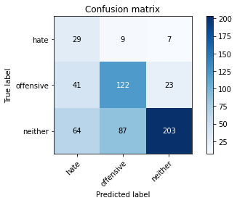

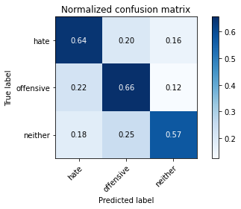

precision recall f1-score support

hate 0.22 0.64 0.32 45

offensive 0.56 0.66 0.60 186

neither 0.87 0.57 0.69 354

accuracy 0.61 585

macro avg 0.55 0.62 0.54 585

weighted avg 0.72 0.61 0.64 585

average eval_loss: 1.3158677101135254, accuracy: 0.6051282051282051

model of 4 epoch

Confusion matrix, without normalization

[[ 40 1 10]

[ 53 64 52]

[ 51 41 273]]

Normalized confusion matrix

[[0.78431373 0.01960784 0.19607843]

[0.31360947 0.37869822 0.30769231]

[0.13972603 0.11232877 0.74794521]]

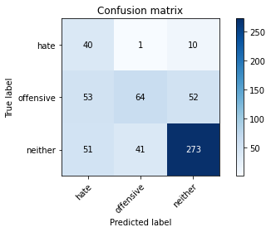

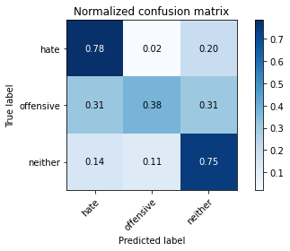

precision recall f1-score support

hate 0.28 0.78 0.41 51

offensive 0.60 0.38 0.47 169

neither 0.81 0.75 0.78 365

accuracy 0.64 585

macro avg 0.57 0.64 0.55 585

weighted avg 0.71 0.64 0.66 585

average eval_loss: 0.9795450925827026, accuracy: 0.6444444444444445

0.6444444444444445

2 run

training 1 epoch...

8.957759857177734 seconds used......

1 training finished! average train loss: 1.0263598987034388

evaluating...

Confusion matrix, without normalization

[[ 16 13 16]

[ 26 121 39]

[ 53 81 220]]

Normalized confusion matrix

[[0.35555556 0.28888889 0.35555556]

[0.13978495 0.65053763 0.20967742]

[0.14971751 0.22881356 0.62146893]]

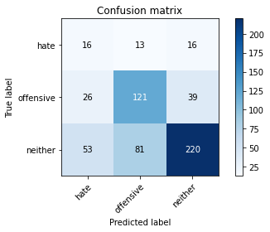

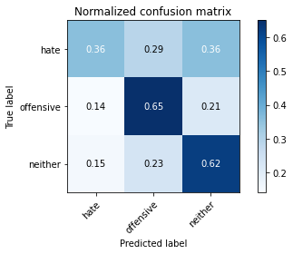

precision recall f1-score support

hate 0.17 0.36 0.23 45

offensive 0.56 0.65 0.60 186

neither 0.80 0.62 0.70 354

accuracy 0.61 585

macro avg 0.51 0.54 0.51 585

weighted avg 0.68 0.61 0.63 585

average eval_loss: 0.8458103199799856, accuracy: 0.6102564102564103

training 2 epoch...

8.931798934936523 seconds used......

2 training finished! average train loss: 0.798907325736114

evaluating...

Confusion matrix, without normalization

[[ 35 3 7]

[ 43 107 36]

[ 70 52 232]]

Normalized confusion matrix

[[0.77777778 0.06666667 0.15555556]

[0.2311828 0.57526882 0.19354839]

[0.19774011 0.14689266 0.65536723]]

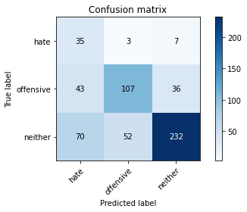

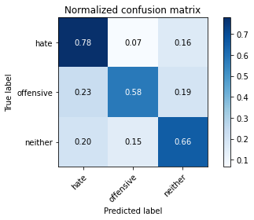

precision recall f1-score support

hate 0.24 0.78 0.36 45

offensive 0.66 0.58 0.61 186

neither 0.84 0.66 0.74 354

accuracy 0.64 585

macro avg 0.58 0.67 0.57 585

weighted avg 0.74 0.64 0.67 585

average eval_loss: 0.8545364638169607, accuracy: 0.6393162393162393

training 3 epoch...

8.926303148269653 seconds used......

3 training finished! average train loss: 0.5248892658523151

evaluating...

Confusion matrix, without normalization

[[ 34 7 4]

[ 38 113 35]

[ 55 68 231]]

Normalized confusion matrix

[[0.75555556 0.15555556 0.08888889]

[0.20430108 0.60752688 0.18817204]

[0.15536723 0.1920904 0.65254237]]

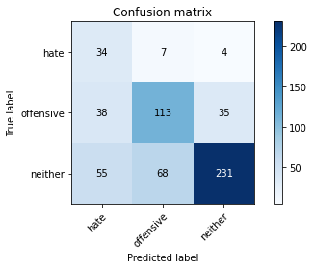

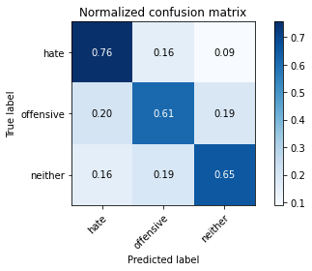

precision recall f1-score support

hate 0.27 0.76 0.40 45

offensive 0.60 0.61 0.60 186

neither 0.86 0.65 0.74 354

accuracy 0.65 585

macro avg 0.57 0.67 0.58 585

weighted avg 0.73 0.65 0.67 585

average eval_loss: 0.9211915989716848, accuracy: 0.6461538461538462

training 4 epoch...

8.952564716339111 seconds used......

4 training finished! average train loss: 0.2731298449050103

evaluating...

Confusion matrix, without normalization

[[ 37 3 5]

[ 62 106 18]

[ 70 101 183]]

Normalized confusion matrix

[[0.82222222 0.06666667 0.11111111]

[0.33333333 0.56989247 0.09677419]

[0.19774011 0.28531073 0.51694915]]

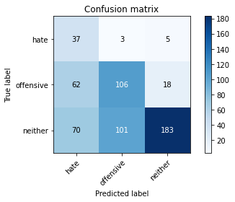

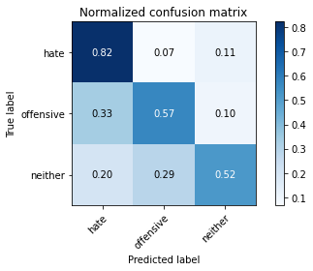

precision recall f1-score support

hate 0.22 0.82 0.35 45

offensive 0.50 0.57 0.54 186

neither 0.89 0.52 0.65 354

accuracy 0.56 585

macro avg 0.54 0.64 0.51 585

weighted avg 0.71 0.56 0.59 585

average eval_loss: 1.4310214420159657, accuracy: 0.5572649572649573

training 5 epoch...

8.96564269065857 seconds used......

5 training finished! average train loss: 0.13082633749581873

evaluating...

Confusion matrix, without normalization

[[ 26 13 6]

[ 22 139 25]

[ 39 93 222]]

Normalized confusion matrix

[[0.57777778 0.28888889 0.13333333]

[0.11827957 0.74731183 0.1344086 ]

[0.11016949 0.26271186 0.62711864]]

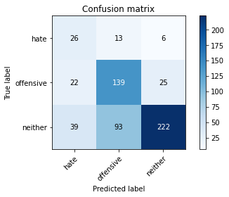

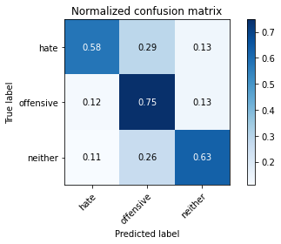

precision recall f1-score support

hate 0.30 0.58 0.39 45

offensive 0.57 0.75 0.65 186

neither 0.88 0.63 0.73 354

accuracy 0.66 585

macro avg 0.58 0.65 0.59 585

weighted avg 0.73 0.66 0.68 585

average eval_loss: 1.2525846978028616, accuracy: 0.6615384615384615

Confusion matrix, without normalization

[[ 40 8 3]

[ 68 84 17]

[ 92 95 178]]

Normalized confusion matrix

[[0.78431373 0.15686275 0.05882353]

[0.40236686 0.49704142 0.10059172]

[0.25205479 0.26027397 0.48767123]]

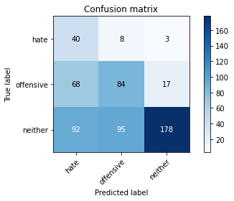

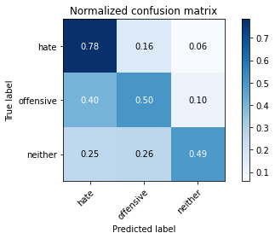

precision recall f1-score support

hate 0.20 0.78 0.32 51

offensive 0.45 0.50 0.47 169

neither 0.90 0.49 0.63 365

accuracy 0.52 585

macro avg 0.52 0.59 0.47 585

weighted avg 0.71 0.52 0.56 585

average eval_loss: 1.5941952506701151, accuracy: 0.5162393162393163

[22]:

0.5162393162393163

3 run

training 1 epoch...

8.924976587295532 seconds used......

1 training finished! average train loss: 1.0441943215472358

evaluating...

Confusion matrix, without normalization

[[ 36 5 4]

[ 88 81 17]

[140 57 157]]

Normalized confusion matrix

[[0.8 0.11111111 0.08888889]

[0.47311828 0.43548387 0.09139785]

[0.39548023 0.16101695 0.44350282]]

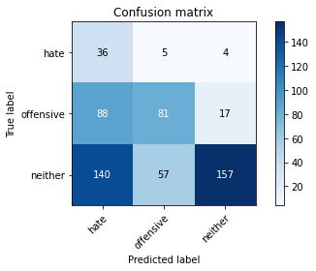

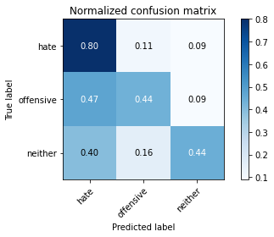

precision recall f1-score support

hate 0.14 0.80 0.23 45

offensive 0.57 0.44 0.49 186

neither 0.88 0.44 0.59 354

accuracy 0.47 585

macro avg 0.53 0.56 0.44 585

weighted avg 0.72 0.47 0.53 585

average eval_loss: 1.0380002697308859, accuracy: 0.4683760683760684

training 2 epoch...

8.951464891433716 seconds used......

2 training finished! average train loss: 0.8188527407390731

evaluating...

Confusion matrix, without normalization

[[ 28 16 1]

[ 29 154 3]

[ 56 202 96]]

Normalized confusion matrix

[[0.62222222 0.35555556 0.02222222]

[0.15591398 0.82795699 0.01612903]

[0.15819209 0.57062147 0.27118644]]

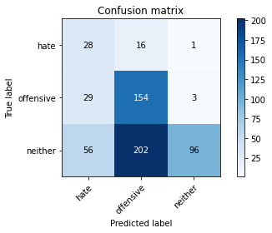

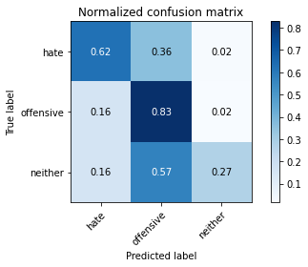

precision recall f1-score support

hate 0.25 0.62 0.35 45

offensive 0.41 0.83 0.55 186

neither 0.96 0.27 0.42 354

accuracy 0.48 585

macro avg 0.54 0.57 0.44 585

weighted avg 0.73 0.48 0.46 585

average eval_loss: 1.1737859964370727, accuracy: 0.4752136752136752

training 3 epoch...

8.939055919647217 seconds used......

3 training finished! average train loss: 0.5515174636883395

evaluating...

Confusion matrix, without normalization

[[ 31 11 3]

[ 32 145 9]

[ 54 172 128]]

Normalized confusion matrix

[[0.68888889 0.24444444 0.06666667]

[0.17204301 0.77956989 0.0483871 ]

[0.15254237 0.48587571 0.36158192]]

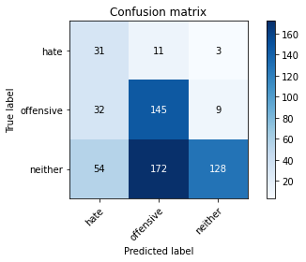

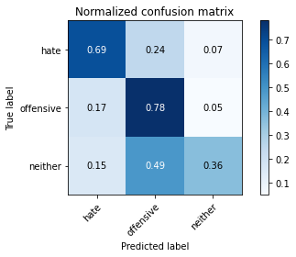

precision recall f1-score support

hate 0.26 0.69 0.38 45

offensive 0.44 0.78 0.56 186

neither 0.91 0.36 0.52 354

accuracy 0.52 585

macro avg 0.54 0.61 0.49 585

weighted avg 0.71 0.52 0.52 585

average eval_loss: 1.1724478205045064, accuracy: 0.5196581196581197

training 4 epoch...

9.0074942111969 seconds used......

4 training finished! average train loss: 0.3622497155198029

evaluating...

Confusion matrix, without normalization

[[ 30 1 14]

[ 42 91 53]

[ 38 32 284]]

Normalized confusion matrix

[[0.66666667 0.02222222 0.31111111]

[0.22580645 0.48924731 0.28494624]

[0.10734463 0.09039548 0.80225989]]

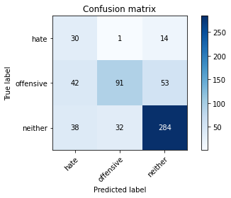

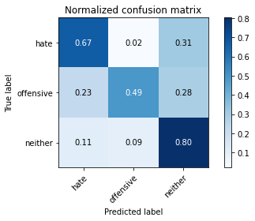

precision recall f1-score support

hate 0.27 0.67 0.39 45

offensive 0.73 0.49 0.59 186

neither 0.81 0.80 0.81 354

accuracy 0.69 585

macro avg 0.61 0.65 0.59 585

weighted avg 0.74 0.69 0.70 585

average eval_loss: 0.8694130003452301, accuracy: 0.6923076923076923

training 5 epoch...

8.943392515182495 seconds used......

5 training finished! average train loss: 0.2018002510469939

evaluating...

Confusion matrix, without normalization

[[ 23 10 12]

[ 25 115 46]

[ 29 62 263]]

Normalized confusion matrix

[[0.51111111 0.22222222 0.26666667]

[0.1344086 0.61827957 0.24731183]

[0.0819209 0.17514124 0.74293785]]

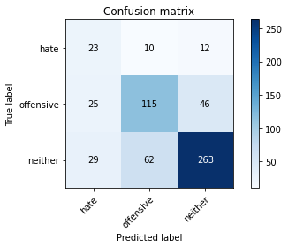

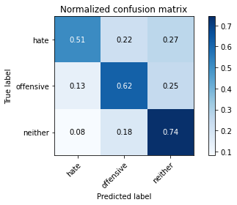

precision recall f1-score support

hate 0.30 0.51 0.38 45

offensive 0.61 0.62 0.62 186

neither 0.82 0.74 0.78 354

accuracy 0.69 585

macro avg 0.58 0.62 0.59 585

weighted avg 0.71 0.69 0.70 585

average eval_loss: 0.9913070440292359, accuracy: 0.6854700854700855

Confusion matrix, without normalization

[[ 41 4 6]

[ 85 65 19]

[154 51 160]]

Normalized confusion matrix

[[0.80392157 0.07843137 0.11764706]

[0.50295858 0.38461538 0.11242604]

[0.42191781 0.13972603 0.43835616]]

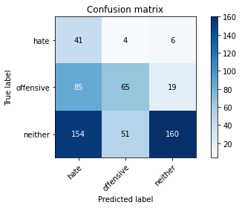

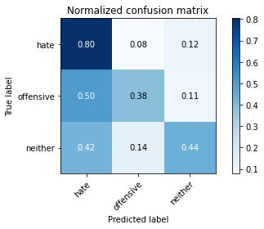

precision recall f1-score support

hate 0.15 0.80 0.25 51

offensive 0.54 0.38 0.45 169

neither 0.86 0.44 0.58 365

accuracy 0.45 585

macro avg 0.52 0.54 0.43 585

weighted avg 0.71 0.45 0.51 585

average eval_loss: 1.0578912854194642, accuracy: 0.4547008547008547

[24]:

0.4547008547008547